Personal data
Hans Steps  Elsloo  +31-6-4414 7171  info@hanssteps.nl  Nationality: Dutch  D.o.B.: 07-Feb-1974  Linkedin: https://www.linkedin.com/in/hanssteps/  Roles: Tester, Test consultant, Scrum master | 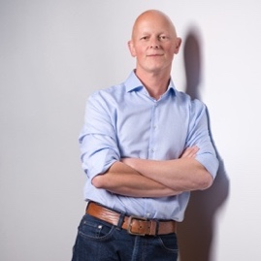 | 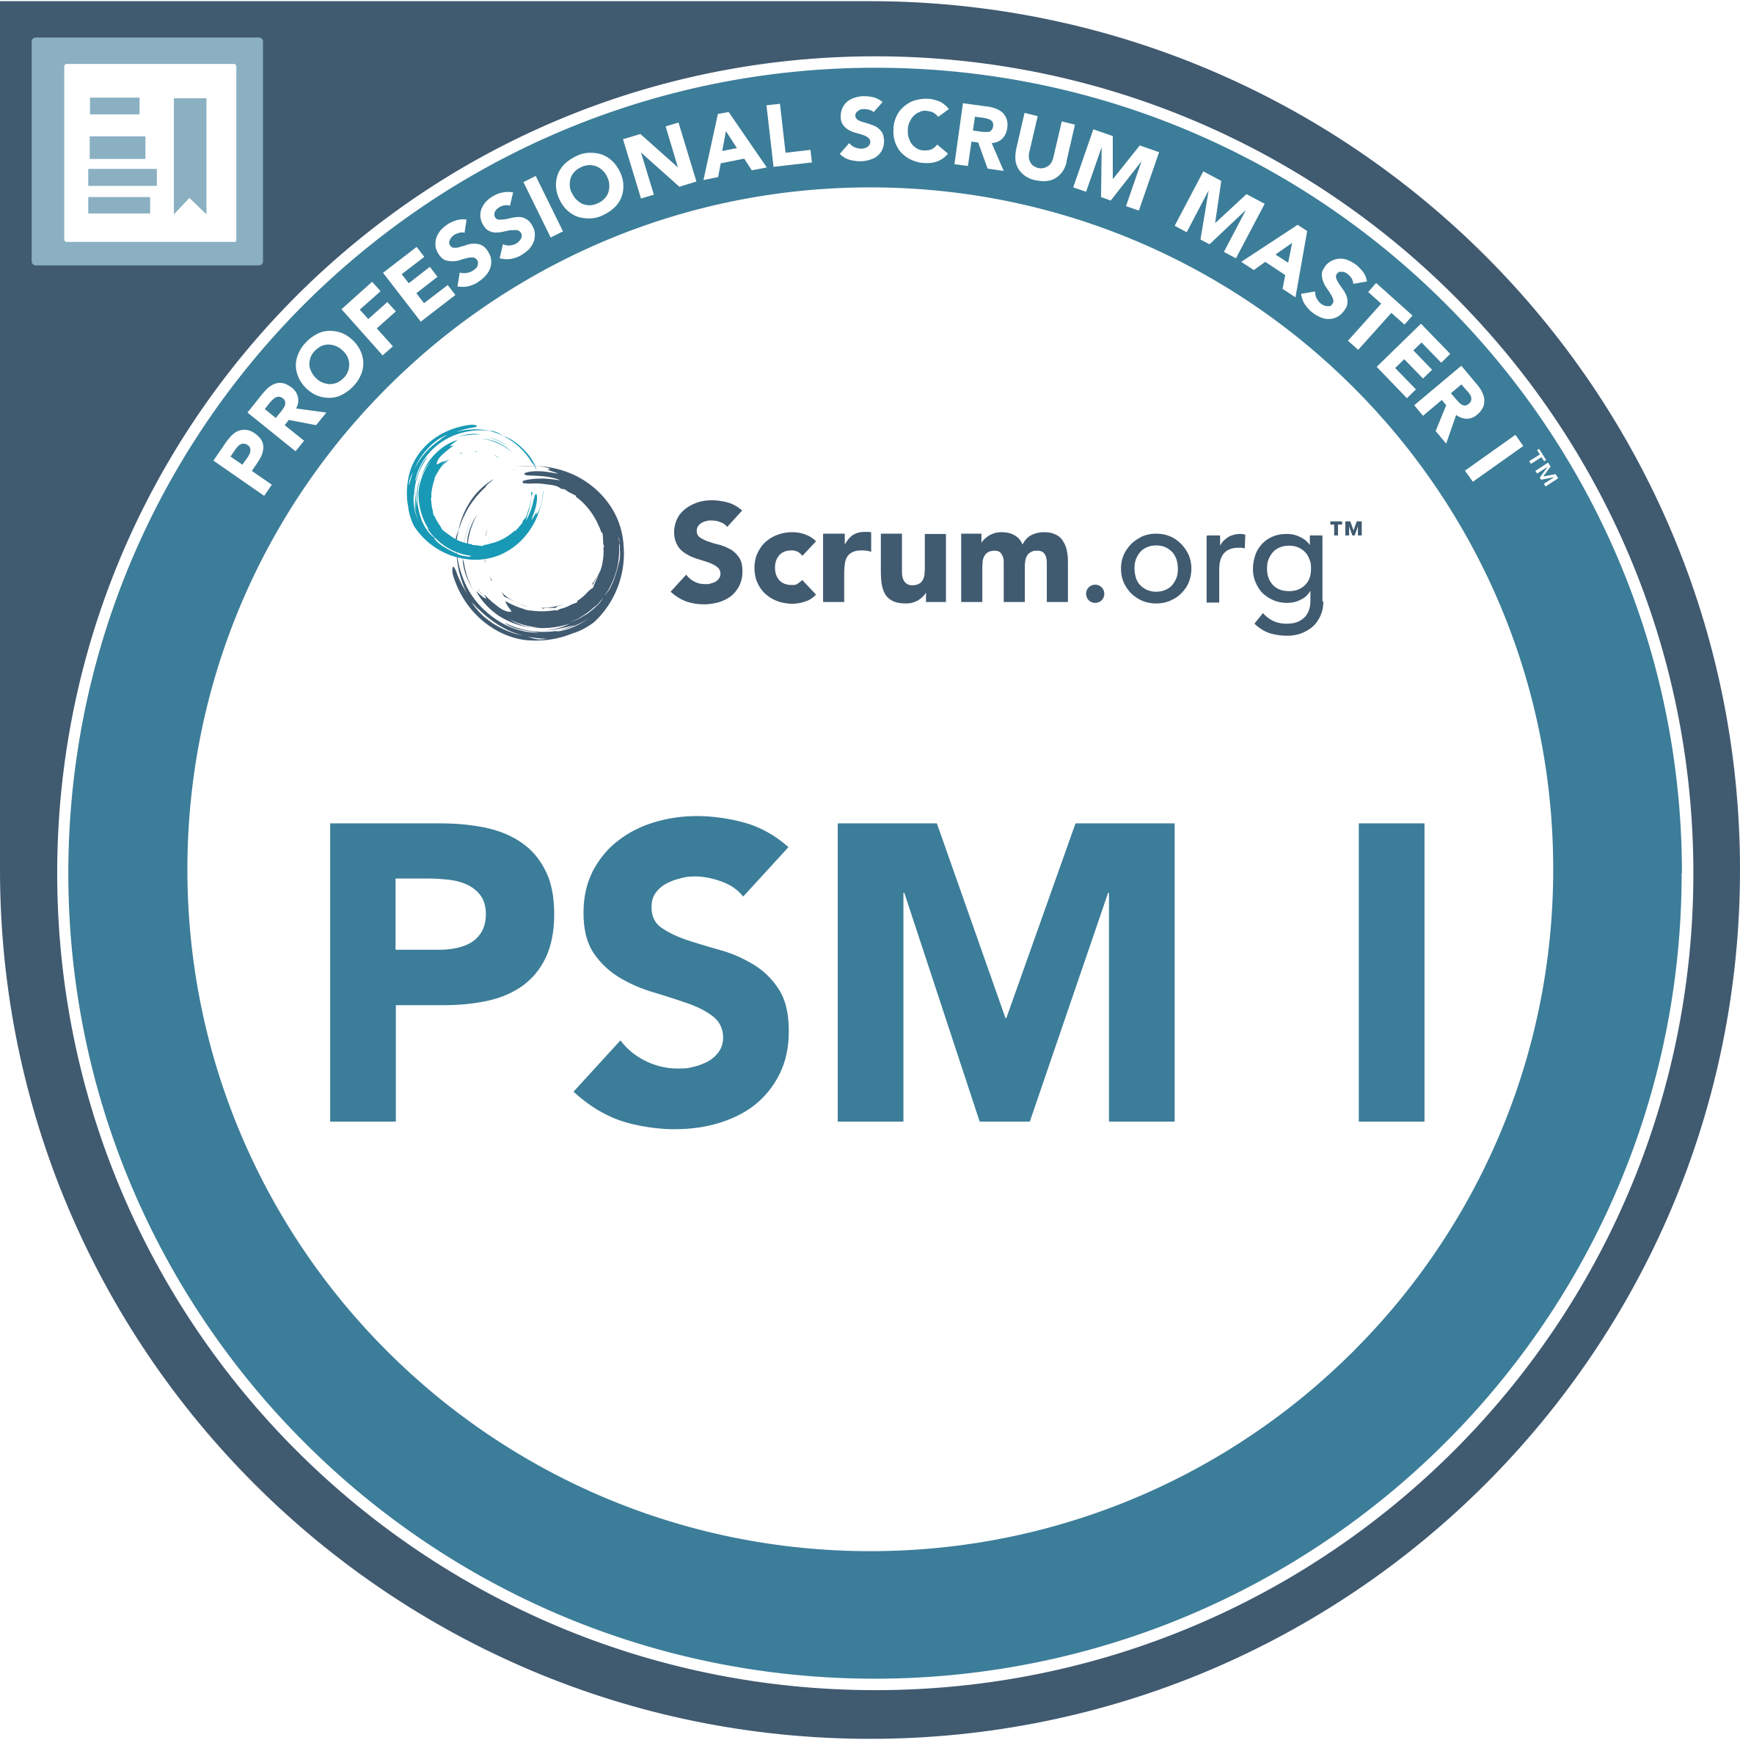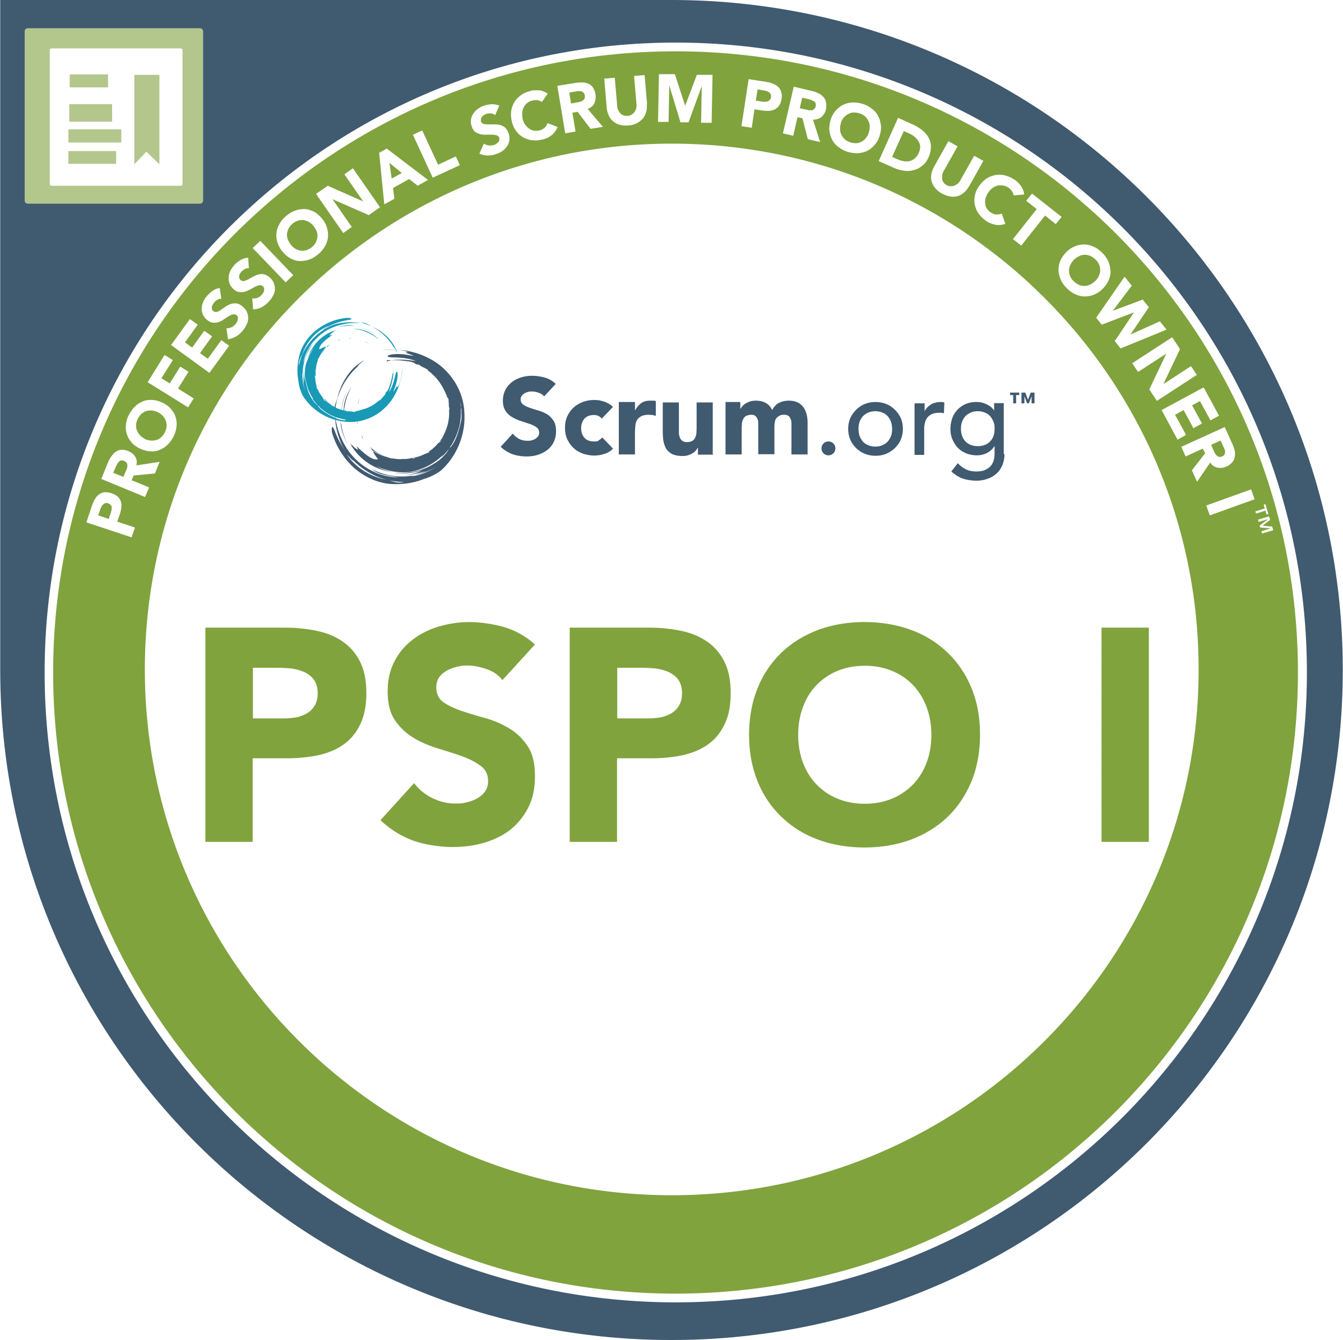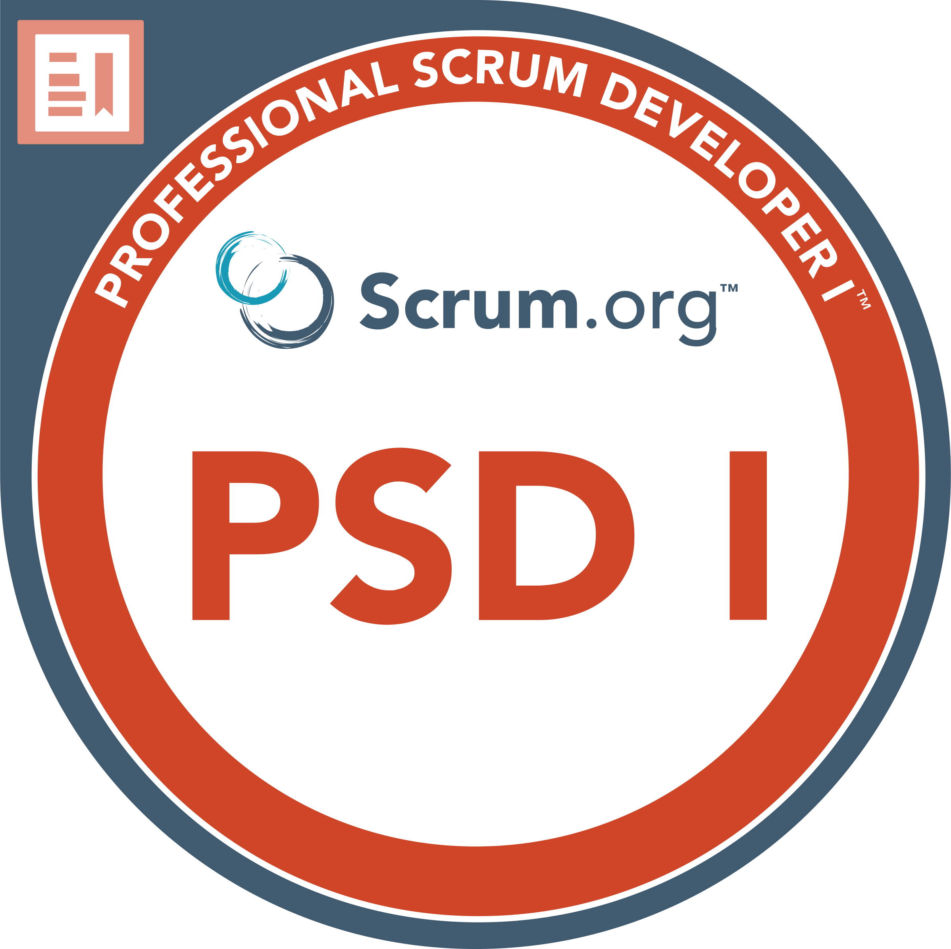  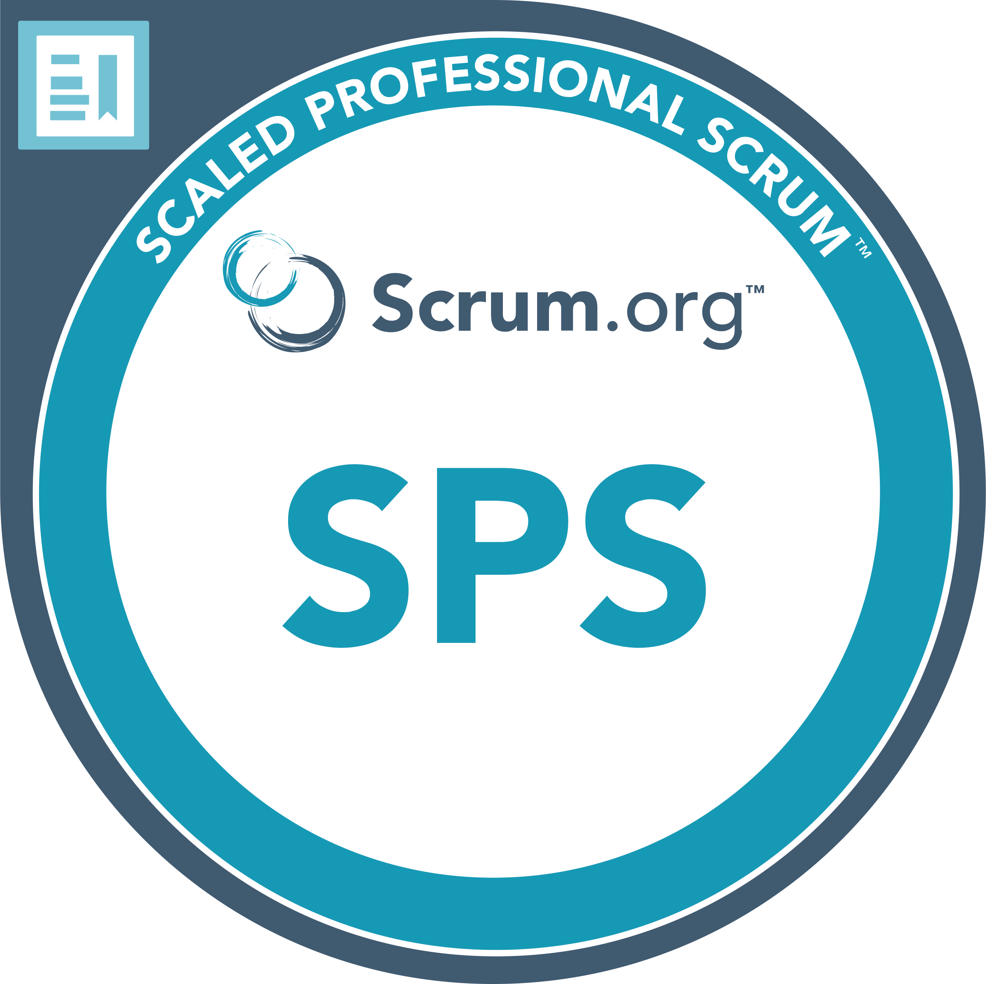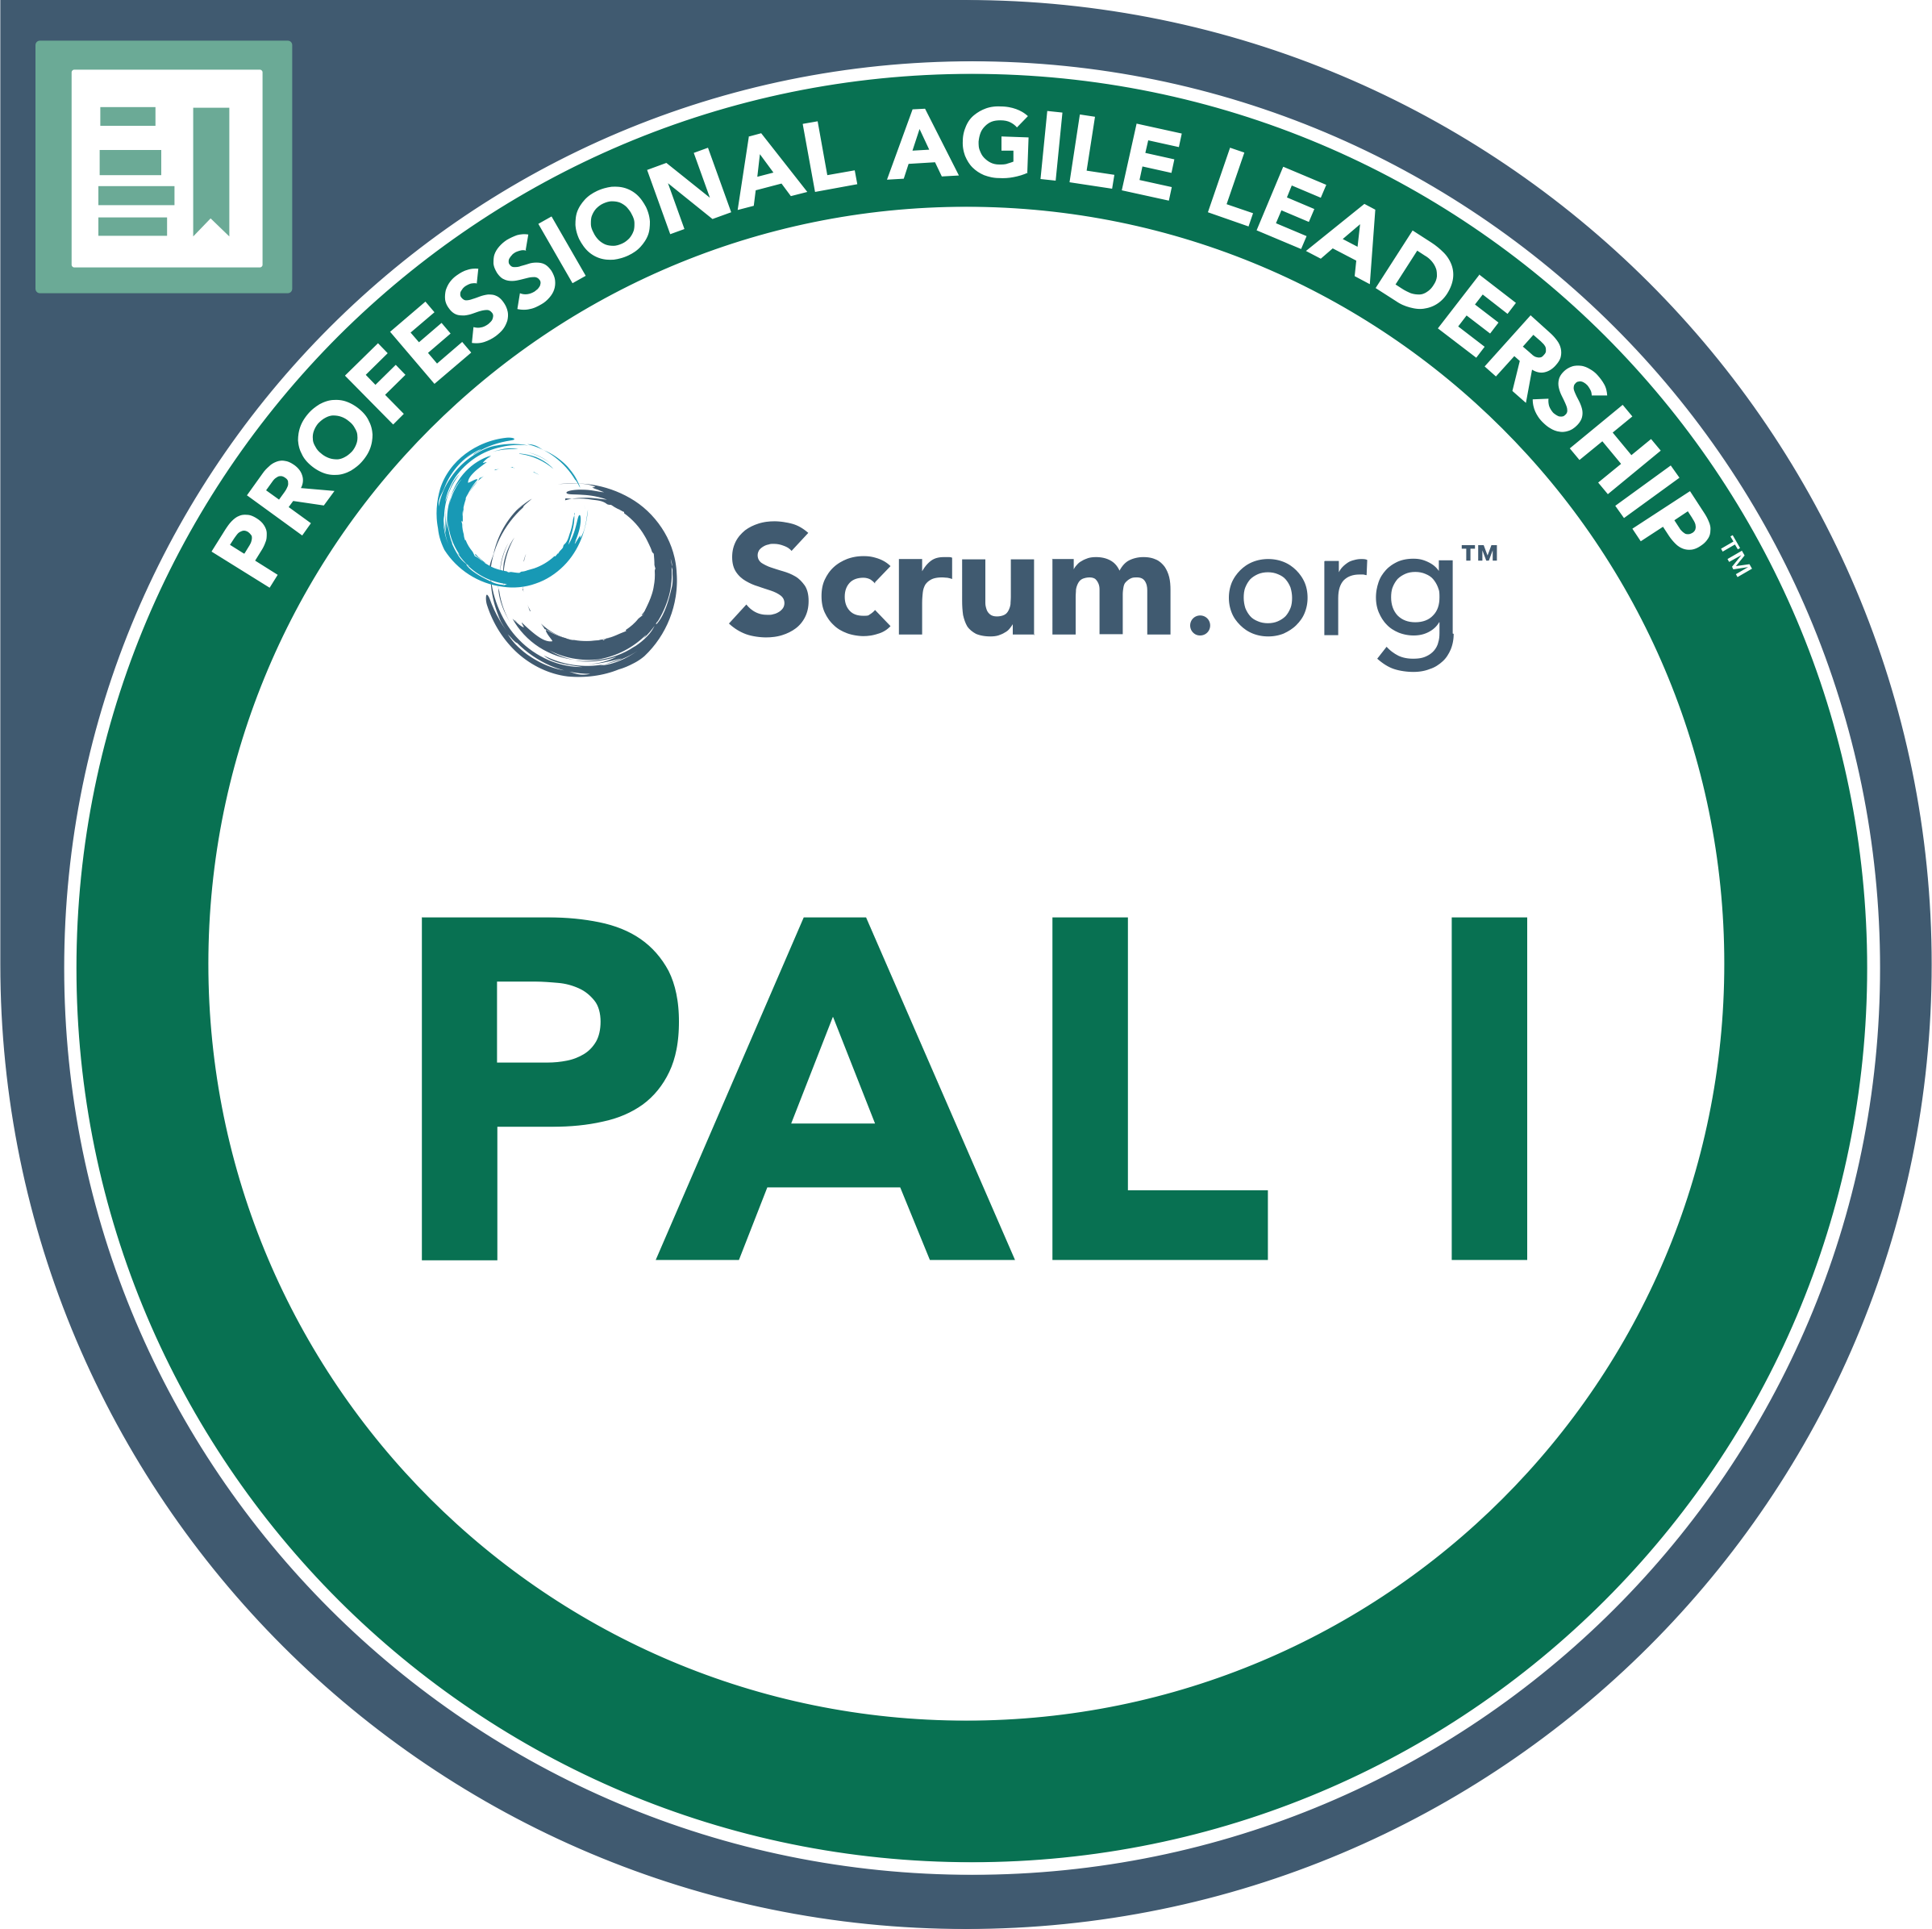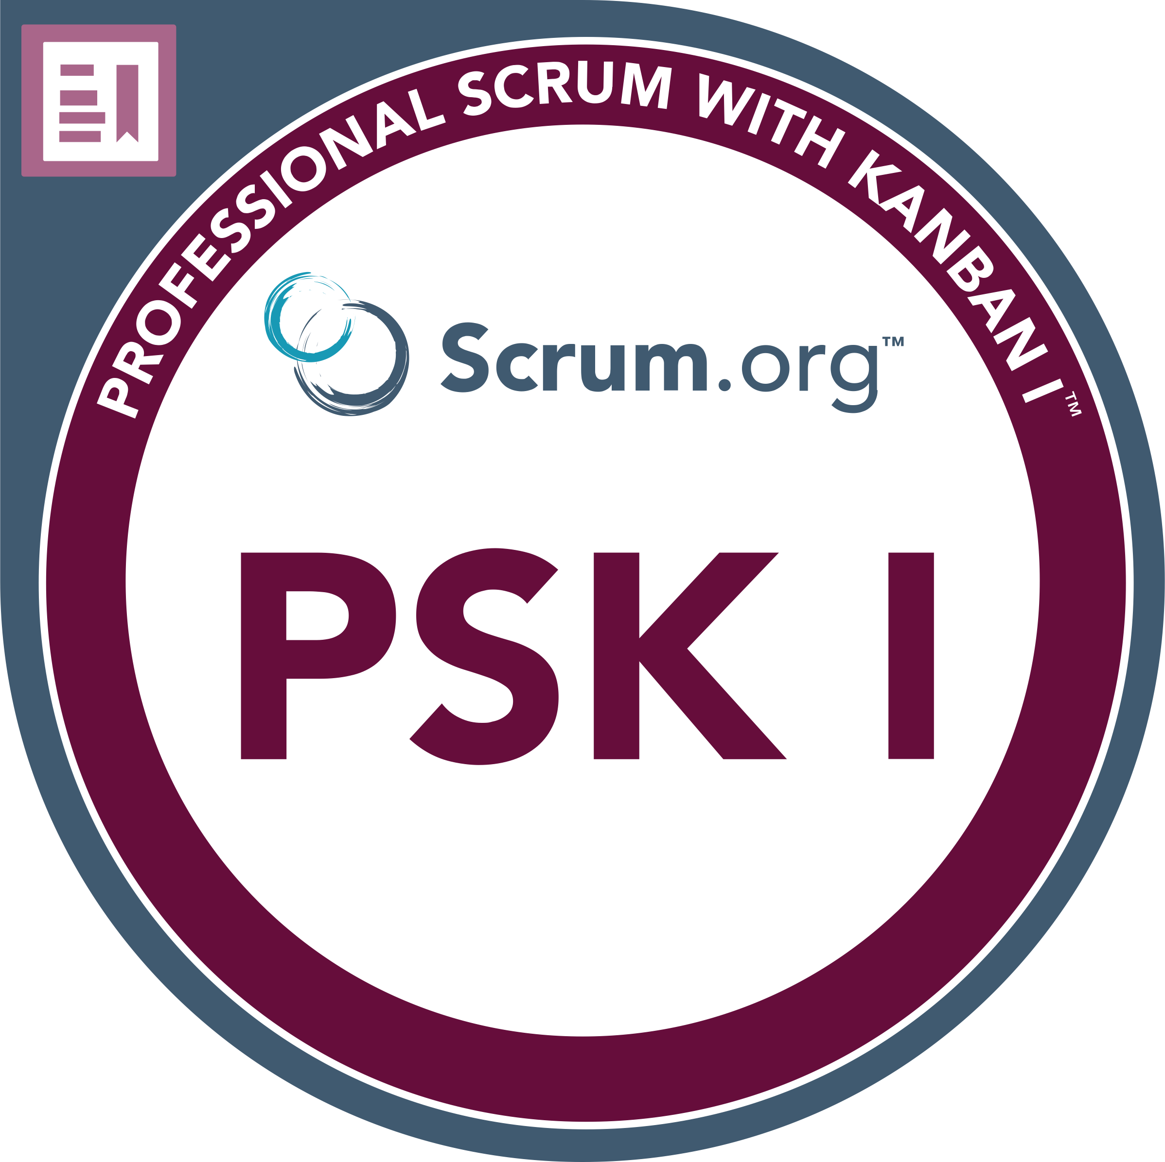

Profile
- 22 years experience in testing complex software products.
- 17 years hands-on testing experience.
- Coached numerous testers.
- Agile/Scrum projects, V-Model, structured testing, creating an out of the box test approach.
- Agronomic: Yara international.
- Automotive: Mercedes-Benz, Car Systems
- Financial: KBC, ABNAmro, BNPParibasfortis, ING, Rabobank, Obvion.
- Healthcare: Atrium Medical Centre, PIE Medical.
- Insurance: Heidelberger Leben, Zwitserleven, Interpolis, Clerical Medical/HBOS.
- Technical: Proximus, Testhuis, Sony, TomTom, Vodafone, OCE, D-Reizen.
- Other: Tjip, Atos Origin, Starbucks.
- Certification: Scrum PSM1, ISTQB foundation, ISTQB Practitioner, TMap, Prince2.

- Latest experience: Scrum, SAFE, Salesforce CRM, Siebel CRM, Tosca test automation, API’s, SoapUI, Postman

Recent work experience (the last 5 years)
Sr. Tester, Mercedes-Benz CAC, Maastricht
August-2020 – today
- SAFE-Agile Salesforce project Sirius, Agile Siebel project Compass CMS MMC
- Siebel-Compass CRM system testing, functional testing of the new functionality, End-End testing and regression testing.
- Creation of around thirty automated regression test scripts in Tricentis Tosca.
- Salesforce CRM system testing, functional testing of the new functionality.
- API testing using SoapUI, Postman and Talend (Chrome plugin) to check vehicle communication towards the CRM system.
- End to end DTMF and InBand telephony simulation of calls initiated by the Mercedes head unit.
- Bi-weekly sprints within a PI of 10 weeks of which the last sprint mainly focuses on cleanup, innovation and planning the next PI.
- Scrum master role after the CMS MMC scrum master left.
- Administration in Jira of user stories, defects, problem and test cases.
- Administration of procedures in Confluence.

- Salesforce inspector, developer console, workbench, SoapUI, Postman, Talend, Tosca, Jira, Confluence, DTMF, E-call router
- Agile/Scrum, SAFE, TMap, ISTQB

Test consultant, Car Systems, Heerlen
February 2019 – June 2020
- Set up agile testing within the scrum teams. Get the testing-load off the PO.
- Manage and monitor the scrum process. Putting responsibilities on the correct roles.
- Help the teams to become more mature in the Scrum process.
- Pick up functional QA, set up Dev-Test feedback loops, help the teams to focus on QA.
- Set up computer aided Selenium testing for regression tests and release tests.
- Perform iOS tests on the Carsys mobile app.
- Applications: Jira, Confluence, Selenium, Eclipse, Cypress.io.
- Approach: Agile/Scrum, TMap, dev-test sessions, risk-based testing, heuristic exploratory testing.

Test lead, Yara international, Brussels/Dulmen/Warsaw/Paris/Varna/Oslo/Berlin
June 2016 – April 2019
- Setup and manage functional testing of an agronomic nutrient management calculation web application (NMP).
- Creating structured calculation test cases based on a number of complex algorithms.
- End to end testing of the integrated applications using JSon outputs as test data.
- Testing the integration of third-party application migrations into the NMP application.
- Test execution of the calculation module, the Shopify website and legal documentation.
- Perform iPad tests on the Webapp
- Regular travel to Brussels, Dulmen, Warsaw, Varna, Oslo, Paris and Berlin.
- Applications: Jira, Confluence, Shopify, Microsoft ALM Team Services, Selenium, Eclipse.
- Approach: Agile/Scrum, V-model, TMap, ISTQB, risk-based testing, dataflow, decision tables, dev-test sessions, heuristic testing.

Further work experience (details to be read on LinkedIn)
- Tester, Proximus, Brussels - March 2016 – June 2016
- Test manager, Starbucks EMEA, Amsterdam - November 2015 – March 2016
- Project delivery manager, Heidelberger Leben Service Management, Heidelberg (DE) - April 2004 – July 2015
- Tester, KBC, Leuven - September 2013 – March 2014
- Test lead, Sony corporate, Zaventem - March 2013 – September 2013
- Test manager/ Release manager, Tjip, Helmond - July 2012 – January 2013
- QA-lead, TomTom, Amsterdam - May 2012 – July 2012
- Tester, BNP Paribas Fortis, Brussels - July 2011 – May 2012
- Test manager, Atrium Medisch Centrum, Kerkrade - January 2010 – June 2011
- Test consultant, Vodafone, Maastricht - December 2010
- Sabbatical - April 2009 – December 2009
- Test lead, ING Bank, Brussels - September 2008 – March 2009
- Test lead, Zwitserleven, Amstelveen - May 2008 – September 2008
- Tester, Interpolis, Tilburg - October 2007 – April 2008
- Test manager, Océ, Venlo - May 2007 – October 2007
- Tester, Obvion, Heerlen - March 2007 – May 2007
- Test lead, D-Reizen, Beverwijk - October 2006 – March 2007
- Test manager / Test lead, Clerical Medical, Maastricht - July 2004 – October 2006
- Tester, Atos Origin, Eindhoven - January 2002 – July 2004
- Tester, Pie Medical Imaging, Maastricht - January 2001 – January 2002

References
- Adrian Nedelcu, Manager, Mercedes-Benz
- Rik Vos, Tester, Mercedes-Benz
- Nico Houben, Director, Car Systems
- Nick Nijenhuis, Developer, Car Systems
- Marion Zouteriks, Scrum master, Car Systems
- Mark Finch, Development lead, Yara international
- Olaf Hilgert, Head of IT, Heidelberger Leben
- Surinder Sharma, Development manager, Heidelberger Leben
- Frederieke Neelissen, Business analyst, Clerical Medical

Courses / Certification  - Professional scrum with Kanban, PSK1  - Professional Scrum Master I, PSM1  - Professional Product Owner I, PSPO1  - Professional Scrum Developer I, PSD1  - Professional Agile Leadership I, PAL1  - Scaled Professional Scrum, SPS  - Prince2 foundation  - TMap professional advanced  - ISTQB practitioner  - ISTQB foundation  - Functional testing and test techniques | Education  - HTS-e telecommunications-TC, Hogeschool van Utrecht, Utrecht - 2000  - MTS-e, Walram college, Sittard - 1996  - Havo, OLC, Sittard - 1993 Ne, En, Du, Wi, Na, Sk, Bi, Ak

Skills & competences
Testing  Phases  System testing  Functional acceptance testing  User acceptance testing  Regression testing  End to end testing  Test techniques  Dataflow  Decision tables  Data combination  Elementary comparison  Boundary value analysis  Roles  Test execution  Test coordination  Test management | Approach  Agile testing  Structured testing  Risk requirement-based testing  Exploratory testing  Heuristic testing  Context driven testing  Applications  Web application testing  Mobile application testing  Desktop application testing  Methods  Scrum  V-Model  Waterfall  Prince2  Test process improvement | SAFE  ISTQB  TMap  Testframe  CMMi  RUP  Tools & interfaces  Tricentis Tosca  Jira  Confluence  HP ALM  Selenium in Eclipse  Cypress.io  SoapUI  Postman  XML  JSon  REST | Systems  Siebel CRM  Salesforce CRM  Languages  Dutch  English  German  French

